**SQL Query Analysis Outputs**

**1./*To create table*/**

CREATE TABLE employee (

employee_id SERIAL PRIMARY KEY,

last_name VARCHAR(100),

first_name VARCHAR(100),

title VARCHAR(100),

reports_to INTEGER,

levels varchar(10),

birthdate DATE,

hiredate DATE,

address VARCHAR(200),

city VARCHAR(100),

state VARCHAR(100),

country VARCHAR(100),

postal_code VARCHAR(20),

phone VARCHAR(50),

fax VARCHAR(50),

email VARCHAR(100),

FOREIGN KEY (reports_to) REFERENCES employee(employee_id)

);

**2./*To import data from excel to sql*/**

COPY employee

FROM 'C:\Users\Sandhya\OneDrive\Desktop\Digital Muasic Store Data Analysis\music store data\music store data\employee.csv'

DELIMITER ','

CSV HEADER;

CREATE TABLE customer (

customer_id INTEGER PRIMARY KEY,

first_name TEXT NOT NULL,

last_name TEXT NOT NULL,

company TEXT,

address TEXT,

city TEXT,

state TEXT,

country TEXT,

postal_code TEXT,

phone TEXT,

fax TEXT,

email TEXT,

support_rep_id INTEGER,

FOREIGN KEY (support_rep_id) REFERENCES employee(employee_id)

);

COPY customer

FROM 'C:\Users\Sandhya\OneDrive\Desktop\Digital Muasic Store Data Analysis\music store data\music store data\customer.csv'

DELIMITER ','

CSV HEADER;

CREATE TABLE invoice (

invoice_id INTEGER PRIMARY KEY,

customer_id INTEGER NOT NULL,

invoice_date DATE NOT NULL,

billing_address TEXT,

billing_city TEXT,

billing_state TEXT,

billing_country TEXT,

billing_postal_code TEXT,

total NUMERIC NOT NULL,

FOREIGN KEY (customer_id) REFERENCES customer(customer_id)

);

COPY invoice

FROM 'C:\Users\Sandhya\OneDrive\Desktop\Digital Muasic Store Data Analysis\music store data\music store data\invoice.csv'

DELIMITER ','

CSV HEADER;

CREATE TABLE invoice_line (

invoice_line_id INTEGER PRIMARY KEY,

invoice_id INTEGER NOT NULL,

track_id INTEGER NOT NULL,

unit_price NUMERIC NOT NULL,

quantity INTEGER NOT NULL,

FOREIGN KEY (invoice_id) REFERENCES invoice(invoice_id),

FOREIGN KEY (track_id) REFERENCES track(track_id)

);

COPY invoice_line

FROM 'C:\Users\Sandhya\OneDrive\Desktop\Digital Muasic Store Data Analysis\music store data\music store data\invoice_line.csv'

DELIMITER ','

CSV HEADER;

CREATE TABLE artist (

artist_id INTEGER PRIMARY KEY,

name TEXT

);

COPY artist

FROM 'C:\Users\Sandhya\OneDrive\Desktop\Digital Muasic Store Data Analysis\music store data\music store data\artist.csv'

DELIMITER ','

CSV HEADER;

CREATE TABLE genre (

genre_id INTEGER PRIMARY KEY,

name TEXT

);

COPY genre

FROM 'C:\Users\Sandhya\OneDrive\Desktop\Digital Muasic Store Data Analysis\music store data\music store data\genre.csv'

DELIMITER ','

CSV HEADER;

CREATE TABLE playlist (

playlist_id INTEGER PRIMARY KEY,

name TEXT

);

COPY playlist

FROM 'C:\Users\Sandhya\OneDrive\Desktop\Digital Muasic Store Data Analysis\music store data\music store data\playlist.csv'

DELIMITER ','

CSV HEADER;

CREATE TABLE album (

album_id INTEGER PRIMARY KEY,

title TEXT NOT NULL,

artist_id INTEGER NOT NULL,

FOREIGN KEY (artist_id) REFERENCES artist(artist_id)

);

COPY album

FROM 'C:\Users\Sandhya\OneDrive\Desktop\Digital Muasic Store Data Analysis\music store data\music store data\album.csv'

DELIMITER ','

CSV HEADER;

CREATE TABLE media_type (

media_type_id INTEGER PRIMARY KEY,

name TEXT

);

COPY media_type

FROM 'C:\Users\Sandhya\OneDrive\Desktop\Digital Muasic Store Data Analysis\music store data\music store data\media_type.csv'

DELIMITER ','

CSV HEADER;

CREATE TABLE track (

track_id INTEGER PRIMARY KEY,

name TEXT NOT NULL,

album_id INTEGER,

media_type_id INTEGER NOT NULL,

genre_id INTEGER,

composer TEXT,

milliseconds INTEGER NOT NULL,

bytes INTEGER,

unit_price NUMERIC NOT NULL,

FOREIGN KEY (album_id) REFERENCES album(album_id),

FOREIGN KEY (media_type_id) REFERENCES media_type(media_type_id),

FOREIGN KEY (genre_id) REFERENCES genre(genre_id)

);

COPY track

FROM 'C:\Users\Sandhya\OneDrive\Desktop\Digital Muasic Store Data Analysis\music store data\music store data\track.csv'

DELIMITER ','

CSV HEADER;

CREATE TABLE playlist_track (

playlist_id INTEGER NOT NULL,

track_id INTEGER NOT NULL,

PRIMARY KEY (playlist_id, track_id),

FOREIGN KEY (playlist_id) REFERENCES playlist(playlist_id),

FOREIGN KEY (track_id) REFERENCES track(track_id)

);

COPY playlist_track

FROM 'C:\Users\Sandhya\OneDrive\Desktop\Digital Muasic Store Data Analysis\music store data\music store data\playlist_track.csv'

DELIMITER ','

CSV HEADER;

**3./* to updating nulls and Check and replacing dublicates */**

SELECT * FROM customer

WHERE customer_id IS NULL OR first_name IS NULL OR last_name IS NULL OR company IS NULL OR

address IS NULL OR city IS NULL OR state IS NULL OR country IS NULL OR postal_code IS NULL OR

phone IS NULL OR fax IS NULL OR email IS NULL OR support_rep_id IS NULL;

UPDATE customer SET company = 'NA' WHERE company IS NULL;

UPDATE customer SET address = 'Not Provided' WHERE address IS NULL;

UPDATE customer SET city = 'Unknown' WHERE city IS NULL;

UPDATE customer SET state = 'Unknown' WHERE state IS NULL;

UPDATE customer SET country = 'Unknown' WHERE country IS NULL;

UPDATE customer SET postal_code = '000000' WHERE postal_code IS NULL;

UPDATE customer SET phone = '000-000-0000' WHERE phone IS NULL;

UPDATE customer SET fax = '000-000-0000' WHERE fax IS NULL;

UPDATE customer SET email = 'noemail@example.com' WHERE email IS NULL;

UPDATE customer SET support_rep_id = 0 WHERE support_rep_id IS NULL;

/*to find null records*/

SELECT * FROM track

WHERE composer IS NULL;

**4./*to update null values*/**

UPDATE track SET composer = 'Unknown Composer' WHERE composer IS NULL;

**5./*to count no. of duplicate records*/**

SELECT name, COUNT(*)

FROM genre

GROUP BY name

HAVING COUNT(*) > 1;

**6./* to remove duplicates from column*/**

DELETE FROM genre

WHERE ctid NOT IN (

SELECT MIN(ctid)

FROM genre

GROUP BY name

);

**7./*Total Revenue by Country*/**

SELECT

c.country,

ROUND(SUM(i.total), 2) AS total_revenue

FROM invoice i

JOIN customer c ON i.customer_id = c.customer_id

GROUP BY c.country

ORDER BY total_revenue DESC;

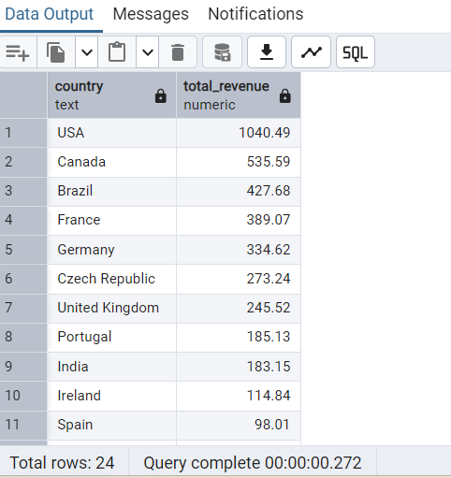

**8./*Customer Count by Country*/**

SELECT

country,

COUNT(customer_id) AS customer_count

FROM customer

GROUP BY country

ORDER BY customer_count DESC

LIMIT 5;

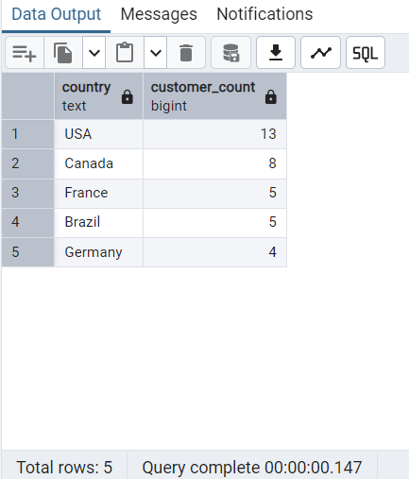

**9./* Monthly Invoice Count*/**

SELECT

DATE_TRUNC('month', invoice_date) AS month,

COUNT(invoice_id) AS invoice_count

FROM invoice

GROUP BY month

ORDER BY month;

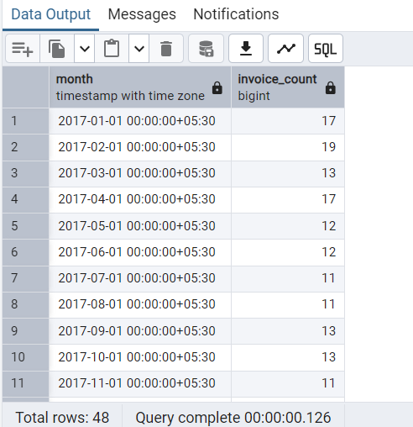

**10./*Top 5 Customers by Total Spending*/**

SELECT

c.first_name || ' ' || c.last_name AS customer_name,

ROUND(SUM(i.total), 2) AS total_spent

FROM invoice i

JOIN customer c ON i.customer_id = c.customer_id

GROUP BY customer_name

ORDER BY total_spent DESC

LIMIT 5;

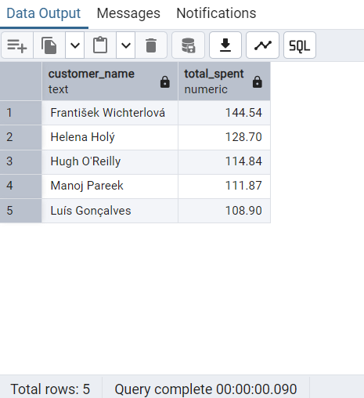

**11./*Top 10 Selling Tracks*/**

SELECT

t.name AS track_name,

SUM(il.quantity) AS units_sold

FROM invoice_line il

JOIN track t ON il.track_id = t.track_id

GROUP BY t.name

ORDER BY units_sold DESC

LIMIT 10;

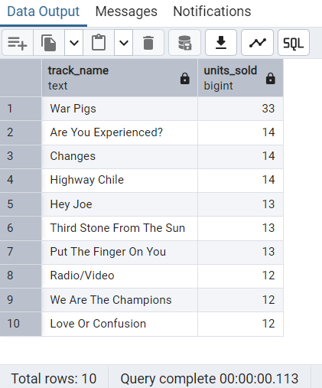

**12./*Revenue by Genre*/**

SELECT

g.name AS genre,

ROUND(SUM(il.unit_price * il.quantity), 2) AS revenue

FROM invoice_line il

JOIN track t ON il.track_id = t.track_id

JOIN genre g ON t.genre_id = g.genre_id

GROUP BY g.name

ORDER BY revenue DESC;

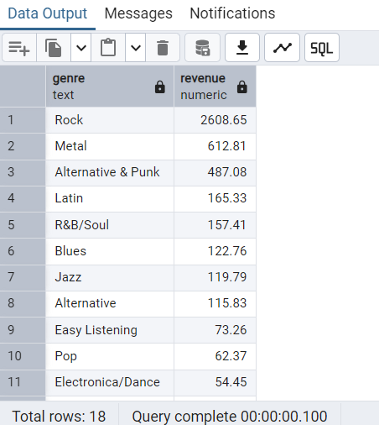

**13./*Most Popular Artists by Sales Volume*/**

SELECT

ar.name AS artist,

SUM(il.quantity) AS total_tracks_sold

FROM invoice_line il

JOIN track t ON il.track_id = t.track_id

JOIN album a ON t.album_id = a.album_id

JOIN artist ar ON a.artist_id = ar.artist_id

GROUP BY ar.name

ORDER BY total_tracks_sold DESC

LIMIT 10;

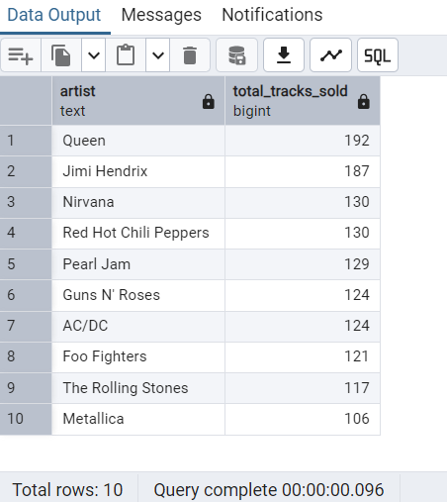

**14./*Most Used Media Types*/**

SELECT

m.name AS media_type,

COUNT(il.invoice_line_id) AS total_sold

FROM invoice_line il

JOIN track t ON il.track_id = t.track_id

JOIN media_type m ON t.media_type_id = m.media_type_id

GROUP BY media_type

ORDER BY total_sold DESC;

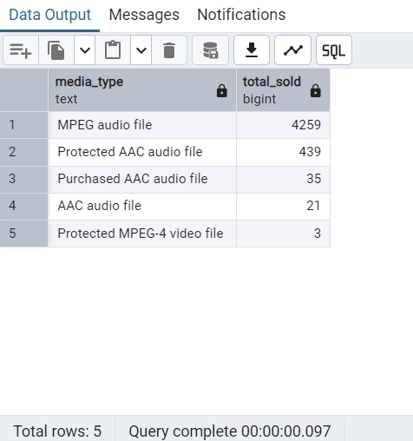

**15./*Monthly Revenue Trend*/**

SELECT

DATE_TRUNC('month', invoice_date) AS month,

ROUND(SUM(total), 2) AS monthly_revenue

FROM invoice

GROUP BY month

ORDER BY month

LIMIT 15;

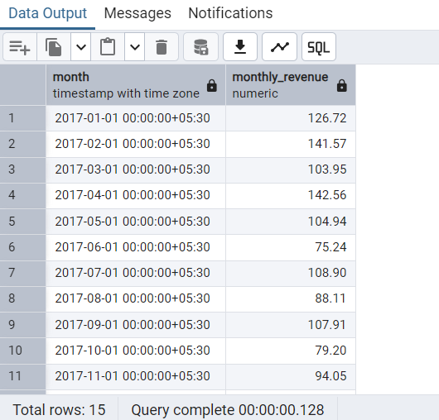

**16./*Top Albums by Revenue*/**

SELECT

a.title AS album_title,

ROUND(SUM(il.unit_price * il.quantity), 2) AS revenue

FROM invoice_line il

JOIN track t ON il.track_id = t.track_id

JOIN album a ON t.album_id = a.album_id

GROUP BY a.title

ORDER BY revenue DESC

LIMIT 10;

